Chapter 6. Overloaded and Overridden Methods
- Overridden Methods :
The rules for overriding a method are as follows:
- The argument list must exactly match that of the overridden method.
- The return type must exactly match that of the overridden method.
- The access level must not be more restrictive than that of the overridden method.
- The access level can be less restrictive than that of the overridden method.
- The overriding method must not throw new or broader checked exceptions
than those declared by the overridden method. For example, a method that
declares a FileNotFoundException cannot be overridden by a method
that declares a SQLException, Exception, or any other non-runtime
exception unless it’s a subclass of FileNotFoundException.
- The overriding method can throw narrower or fewer exceptions. Just because
an overridden method “takes risks” doesn’t mean that the overriding subclass’
exception takes the same risks. Bottom line: An overriding method doesn’t
have to declare any exceptions that it will never throw, regardless of what
the overridden method declares.
- You cannot override a method marked final.
- If a method can’t be inherited, you cannot override it.
- Example for overriding methods :
Let’s take a look at overriding the eat() method of Animal:

public class Animal {
public void eat() { }
}
Below table shows the illegal overrides of the method eat() in a subclass.
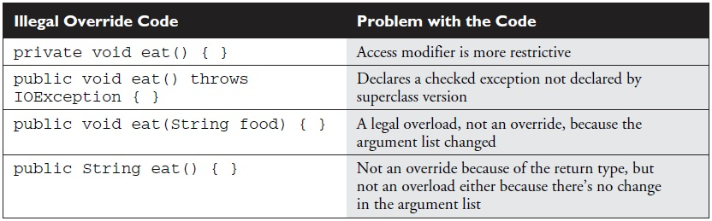

- Overloaded Methods :
Rules for overloading a methods are as below
- Overloaded methods must change the argument list.
- Overloaded methods can change the return type.
- Overloaded methods can change the access modifier.
- Overloaded methods can declare new or broader checked exceptions.
- A method can be overloaded in the same class or in a subclass.
- Example for Overloading methods
Example 1:
public class Animal {
public void eat() {
System.out.println("Generic Animal Eating Generically");
}
}
public class Horse extends Animal {
public void eat() {
System.out.println("Horse eating hay ");
}
public void eat(String s) {
System.out.println("Horse eating " + s);
}
}

Notice that the Horse class has both overloaded and overridden the eat() method.
Table below shows which version of the three eat() methods will run depending on
how they are invoked.
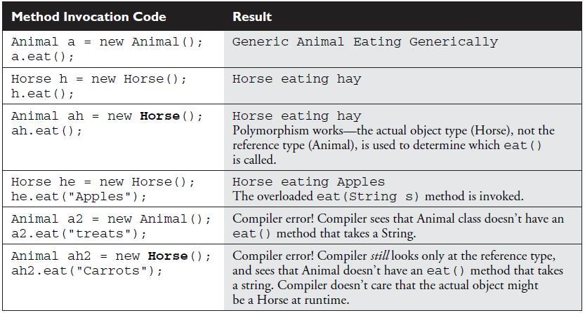

Example 2:
package OverloadingnArrays;

public class OverloadedCls {

void meth(int i)
{
System.out.println("Integer value is "+i);
}
char [] meth(String str)
{
return str.toCharArray();
}
private void meth()
{
System.out.println("private meth");
}
void meth(int i,int j)
{
System.out.println("two args "+i+" & "+j);
}

public static void main(String[] args)
{
OverloadedCls oc = new OverloadedCls();
oc.meth(10);
System.out.println(oc.meth("java"));
oc.meth(5, 15);
oc.meth();
}
}
Output:
Integer value is 10
java
two args 5 & 15
private meth

In the above example we can see how method arguments, return type, access control changes works with overloaded methods.

Example 2
class BaseClass
{
int a=5,b=5;
int sumInt()
{
int sum = 0;
sum = a+b;
return sum;
}

void printSum(BaseClass obj)
{
System.out.println("this is base class method "+obj.sumInt());
}
}

class DerivedClass extends BaseClass
{
int i=10,j=10;
int sumInt()
{
int sum = 0;
sum = i+j;
return sum;
}
}

public class PolymrphClass
{
public static void main(String[] args)
{
// TODO Auto-generated method stub
BaseClass bc = new BaseClass();
DerivedClass dc = new DerivedClass();
System.out.println(bc.sumInt());
System.out.println(dc.sumInt());

bc.printSum(dc);

bc = dc;
System.out.println(bc.sumInt());
}
}
Output:
10
20
this is base class method 20
20

- Difference between overloaded and overridden methods are as follows

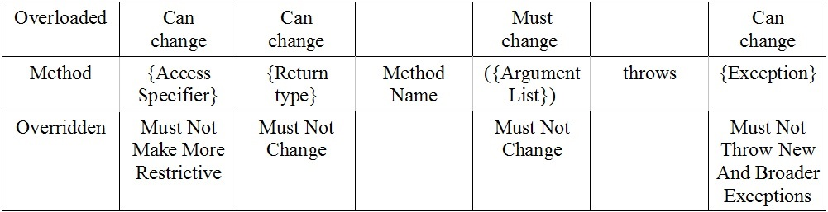
Access Modifiers :
- There are three access modifiers public, private and protected but there are four access control default being the fourth.
- A class could have only 2 out of 4 access control. They are public and default.
Default access : Its a package level access and any class A in package x cannot be a super class of a class B in package Y. i.e. default modifier makes class invisible outside the package. When no modifier is used for a class then it considered as default modifier.
Ex: class Beverage {} has default access.
Public access : When a class is marked with public modifier then it is available to all the classes virtually in the java universe.
Ex: public class Beverage {}
- Member Access :
- All the four access controls will be used by class members.
- It is always better to check class modifier before member modifiers for faster understanding.
- public : When a member variable or method is declared public then it means all other classes regardless of package have access to it(assuming the class is visible outside package).
Ex :
package book;
import cert.*; // Import all classes in the cert package
class Goo {
public static void main(String [] args) {
Sludge o = new Sludge();
o.testIt();
}
}

Now look at the second file

package cert;
public class Sludge {
public void testIt() {
System.out.println("sludge");
}
}
Also when a member of a super class is declared public then subclass will inherits that member regardless of both classes are in the same package. Hence (.) operator i.e. reference is not needed to use those members. In above example testIt() method could be directly called.
Example
class InheritorMethCheck1
{
void meth1()
{
System.out.println("Inside meth1");
}
}

class InheritorMethCheck2 extends InheritorMethCheck1
{
void meth2()
{
meth1();
System.out.println("Inside meth2");
}
}

public class InheritorMethCheck {

public static void main(String[] args)
{
InheritorMethCheck2 imc = new InheritorMethCheck2();
imc.meth2();
}
}
Output:
Inside meth1
Inside meth2
- Private :
Members marked private could be used by only the class in which they are defined, for other classes they are invisible.
- Ex :
package chapter2;

class PrivateMemberClass1
{
private int a=10, b=10;
int c = 20;
private int addint()
{
int sum = 0;
sum = a+b;
return sum;
}
int mulint()
{
int mul;
mul=a*b;
return mul;
}
}
public class PrivateMemberClass {
/*Private members cannot be used outside the same class */
public static void main(String[] args) {
PrivateMemberClass1 prcls = new PrivateMemberClass1();
//System.out.println(prcls.addint());//dont compile
//System.out.println(prcls.a); //dont compile System.out.println(prcls.c);
System.out.println(prcls.mulint());
}
}

If we try to remove comment line for method addint() then compiler will give following error.

Exception in thread "main" java.lang.Error: Unresolved compilation problem:
The method addint() from the type PrivateMemberClass1 is not visible
at chapter2.PrivateMemberClass.main(PrivateMemberClass.java:24)

- Even for a subclass, superclass private members are invisible. When subclass declares a method of the same name following all the rules of overriding even then the method wont considered overridden as superclass method is invisible.
- It is always better to mark member variables as private and give access to them through public methods. For example if cat class have variable weight then it could take a negative value hence giving access through methods is a better solution where one can make a check for valid values.
- Effect of public and private modifiers on classes from same or diff packages is shown below.

- Protected and Default :
protected and default modifiers are same with only one difference. default modifier is only for package level and no class outside package access those members by reference or inheritance. But with protected modifier a class in one package can inherit(that means only through subclass and not be reference i.e. (.) operator ) protected members of another package. Hence one can say default is only for package level but protected is for package+kids.
- If Class A of package 1 has protected members and if it has been extended by Class B of package 2 then Class B will have access to protected members of Class A. But what if Class C in package 2 extends Class B of same package. Does Class C will also have access to protected members of Class A. NO. Because protected members in subclass becomes private members of it and wont be visible to other subclasses.
- The effect of default and protected access is shown below

- Summary :

